Project Design Phase-II
Data Flow Diagram & User Stories
Date | 19 July 2026
Team ID
Project Name | Darshan Ease – Temple Darshan Ticket Booking App
Maximum Marks | 4 Marks
Data Flow Diagrams:
A Data Flow Diagram (DFD) is a visual representation of the information flows within a system. A neat, clear DFD depicts system requirements graphically — showing how data enters and leaves the system, what changes the information, and where it is stored.
Level 0 – Context Diagram
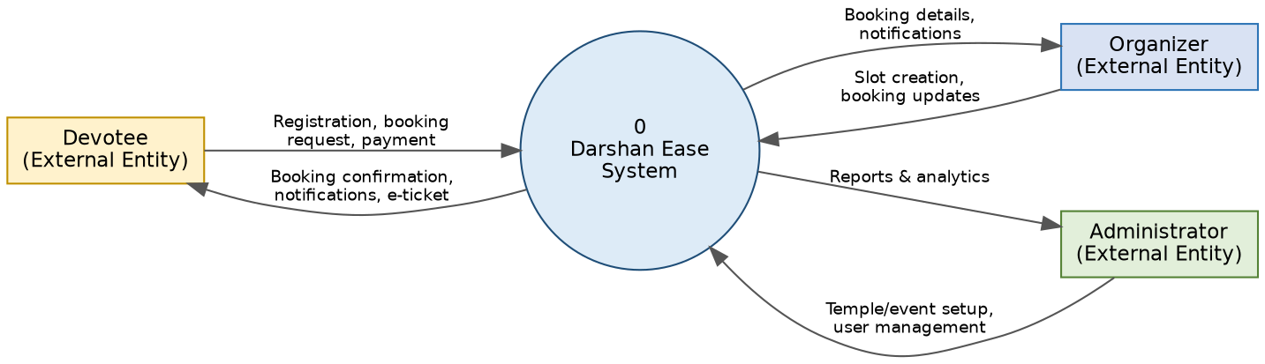
Figure 1: Level 0 DFD — Darshan Ease system context
Level 1 – Process Breakdown
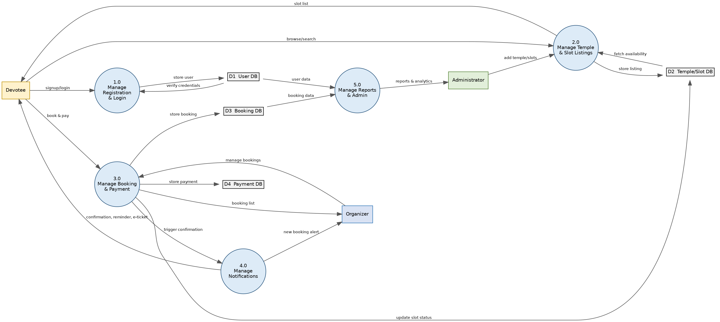
Figure 2: Level 1 DFD — key processes and data stores

User Stories
Use the table below to list all the user stories for Darshan Ease.
User Type | Functional Requirement (Epic) | User Story Number | User Story / Task | Acceptance Criteria | Priority | Release
Devotee (Mobile user) | Registration | USN-1 | As a devotee, I can register for the application by entering my email, password, and confirming my password. | I can access my account/dashboard after registering. | High | Sprint-1
 |  | USN-2 | As a devotee, I receive a confirmation email once I have registered for the application. | I receive the confirmation email and can click confirm. | High | Sprint-1
 |  | USN-3 | As a devotee, I can register for the application through Google login. | I can register and access the dashboard using Google login. | Medium | Sprint-2
 | Login | USN-4 | As a devotee, I can log into the application using my registered email and password. | I land on my dashboard after a successful login. | High | Sprint-1
 | Browse & Book Darshan | USN-5 | As a devotee, I can search for a temple by name or city. | Matching temples are displayed in a list. | High | Sprint-1
 |  | USN-6 | As a devotee, I can view available darshan slots and pooja types for a selected date. | A slot list with timing and price is shown. | High | Sprint-1
 |  | USN-7 | As a devotee, I can book a darshan slot and enter accompanying devotee details. | The booking is saved and the slot count is reduced. | High | Sprint-1
 |  | USN-8 | As a devotee, I can pay for my booking online. | A payment confirmation is shown and a receipt is generated. | High | Sprint-2
 | Booking Management | USN-9 | As a devotee, I can view my booking history. | All past and upcoming bookings are listed. | Medium | Sprint-2
 |  | USN-10 | As a devotee, I can cancel or reschedule a booking. | The slot is released and a confirmation is shown. | Medium | Sprint-3
 |  | USN-11 | As a devotee, I receive a reminder notification before my darshan date. | A notification is sent one day before the booked date. | Medium | Sprint-2
 | Feedback | USN-12 | As a devotee, I can rate and review my darshan experience. | My rating is stored and visible to the admin. | Low | Sprint-3
Devotee (Web user) | Dashboard | USN-13 | As a web user, I can view my dashboard with upcoming bookings and temple recommendations. | The dashboard loads with correct, up-to-date data. | Medium | Sprint-2
Organizer | Slot Management | USN-14 | As an organizer, I can create and update darshan slots for my temple. | New/updated slots appear for devotees to book. | High | Sprint-1
 |  | USN-15 | As an organizer, I can view and manage devotee bookings for my slots. | A booking list with devotee details is visible. | High | Sprint-2
 |  | USN-16 | As an organizer, I receive a notification for each new booking. | An alert is received in real time. | Medium | Sprint-2
Administrator | Temple & User Management | USN-17 | As an admin, I can add, edit, or remove temples and events on the platform. | Changes are reflected immediately for devotees. | High | Sprint-1
 |  | USN-18 | As an admin, I can manage organizer and devotee accounts. | I can activate or deactivate any account. | High | Sprint-2
 | Reporting | USN-19 | As an admin, I can view booking and revenue reports. | Reports can be filtered by temple and date range. | Medium | Sprint-3

